**“E-Commerce Website Using MERN Tech Stack”**

Submitted in partial fulfillment of the requirements of the degree

**B.Tech. (Computer Engineering)**

By,

#### Deeptanshu Lal Roll No. 22CE1285

#### Krish Pradeshi Roll No. 22CE1232

Supervisor

**Mrs. Shital Patil**



Department of Computer Engineering Ramrao Adik Institute of Technology,

Sector 7, Nerul, Navi Mumbai

(Under the ambit of D. Y. Patil Deemed to be University)

**April 2024**



#### Ramrao Adik Institute of Technology

(Under the ambit of D. Y. Patil Deemed to be University)

Dr. D. Y. Patil Vidyanagar, Sector 7, Nerul, Navi Mumbai 400 706.

# Certificate

This is to certify that, the Mini Project- II entitled

**“E-Commerce Product Catalog”**

is a bonafide work done by,

**Deeptanshu Lal Roll No. 22CE1285**

**Krish Pradeshi Roll No. 22CE1232**

and is submitted in the partial fulfillment of the requirement for the degree of

**B. Tech. in Computer Engineering**

to the

**D. Y. Patil Deemed to be University.**

Supervisor

**(Mrs. Shital Patil)**





# Approval Sheet

This Mini Project - II entitled **“E-Commerce Product** **Catalog”** by **Deeptanshu Lal Roll No. 22CE1285, Krish Pradeshi Roll No. 22CE1232** is approved in the partial fulfillment of the requirement for the degree of **B. Tech. in Computer Engineering.**

**Examiners**

**1………………………………………**

(Internal Examiner Name & Sign)

**2…………………………………………**

(External Examiner name & Sign)

Date:

Place:

ii

### Abstract

In the digital era, e-commerce platforms have revolutionized the way businesses present and market their products to consumers worldwide. The e-commerce catalog serves as a pivotal tool in this landscape, providing a structured, visual, and interactive representation of available products and services. The primary objective of an e-commerce catalog is to offer users a seamless and intuitive browsing experience, enabling them to explore products, gather information, and make informed purchase decisions. It amalgamates product details such as images, descriptions, specifications, pricing, and reviews into a cohesive and accessible format. The catalog's design emphasizes user-friendliness, ensuring that customers can effortlessly navigate through categories, filter results, and access relevant information.

#### Contents

1. Introduction
   1. Overview
   2. Motivation
   3. Problem Statement and Objectives
2. Literature Survey
   1. Survey of Existing System
   2. Limitations of Existing System
3. Proposed System
   1. Problem Statement
   2. Proposed Methodology / Techniques
   3. System Design
   4. Details of Hardware and Software Requirements
4. Results and Discussion
   1. Implementation Details
   2. Project Outcomes
5. Conclusion and Future Work

* References
* Appendix
  + Weekly progress report.
* Acknowledgement

## Chapter 1 Introduction

## In the realm of digital commerce, the e-commerce catalogue emerges as a cornerstone, defining the online shopping journey for global consumers. Serving as a digital shopfront, an e-commerce catalogue meticulously organizes and showcases a curated selection of products and services, enriching the browsing experience with accessibility and visual allure. This introduction delves into the essence, evolution, and technological significance of e-commerce catalogues, particularly within the context of our mini-project.

## Within our technical exploration, e-commerce catalogues play a pivotal role in orchestrating user interactions, shaping backend functionalities, and driving frontend engagements. Through a lens of technology, these catalogues serve as dynamic databases, efficiently managing product information, categories, and user preferences. Leveraging frameworks like the MERN (MongoDB, Express.js, React.js, Node.js) stack, our mini-project encapsulates the essence of modern web development, intertwining data management, server-side scripting, and client-side rendering to construct a robust e-commerce catalogue system.

## 

## Motivation:

The core drive for selecting the MERN Tech Stack and embarking on this project was to gain hands-on experience with real-world website development and understand the intricate workings involved. It's been a journey to grasp the depth of effort required in creating a fully functional platform. This endeavor serves as an invaluable opportunity to immerse oneself in the nuances of real-world application, gaining insights into the intricate processes involved. Through this journey, I aim to not only expand my technical skill set but also cultivate a deeper understanding of the holistic framework that underpins modern web development.

## Objectives:

The primary objectives include:

1. **Strengthening Technical Proficiency:** The primary objective of selecting the MERN (MongoDB, Express.js, React.js, Node.js) Tech Stack for this project is to foster a deeper understanding of contemporary web development practices. By immersing ourselves in the intricacies of these technologies, we aim to enhance our technical proficiency and gain practical insights into the complexities of building a fully functional e-commerce platform.
2. **Exploring Software Architecture:** By delving into the architecture of a MERN-based application, we seek to gain a comprehensive understanding of its structural components and their interrelationships. This includes exploring concepts such as the Model-View-Controller (MVC) pattern, RESTful API design, state management in React, and database integration with MongoDB.
3. **Building Brand Identity and Brand Aesthetics:** To communicate the brand's values, identity, and value proposition through consistent branding elements, compelling visuals, and engaging content that resonate with the target audience.

## Chapter 2 Literature Survey

A survey of technologies and methodologies used in existing e-commerce catalog systems revealed a diverse range of approaches. Commonly employed technologies include the MERN stack (MongoDB, Express.js, React.js, Node.js), as well as traditional LAMP (Linux, Apache, MySQL, PHP) and MEAN (MongoDB, Express.js, AngularJS, Node.js) stacks. Methodologies such as Agile and Scrum are widely adopted for project management, while RESTful APIs and microservices architecture are favored for system scalability.

"Building E-commerce Sites with Drupal Commerce Cookbook" is a valuable resource for anyone looking to harness the power of Drupal Commerce to create robust and scalable e-commerce solutions. Whether you're a beginner getting started with Drupal Commerce or an experienced developer looking to expand your skills, this book provides practical insights and actionable advice to help you succeed in your e-commerce projects. The book is structured as a collection of recipes, each focusing on a specific aspect of building and customizing e-commerce sites with Drupal Commerce. It covers a wide range of topics, including setting up Drupal Commerce, configuring product catalogs and categories, managing orders and payments, implementing shipping.

## Limitation of Existing System

**Product Information Accuracy:** Maintaining accurate and up-to-date product information is challenging. Prices, stock availability, product descriptions, and images need regular updates, and discrepancies can lead to customer dissatisfaction.

**Scalability Issues**: As a business grows and adds more products to its catalog, managing and organizing them can become complex. This can affect the performance and user experience of the e-commerce platform.

**Product Representation:** Representing physical products accurately through digital means is challenging. Customers can't touch or feel products, so providing detailed descriptions, images, and videos becomes crucial. However, conveying all product details effectively can be challenging.

**Mobile Responsiveness:** As more customers shop using mobile devices, ensuring that the e-commerce catalog is optimized for various screen sizes and devices is crucial.

However, managing a responsive catalog that provides a consistent user experience across devices can be challenging.

**Cost of Maintenance:** Regularly updating, optimizing, and managing an e-commerce catalog requires resources, including manpower and technology. The ongoing cost of maintaining a comprehensive and user-friendly catalog can be significant for businesses.

## Chapter 3

### Problem Statement

Project aims to develop a user-friendly e-commerce platform with organized project structure, backend functionality for product and user management, and frontend features including shopping cart functionality, product search, and responsive design. Deployment and documentation will ensure accessibility and reliability of the platform.

### System Design

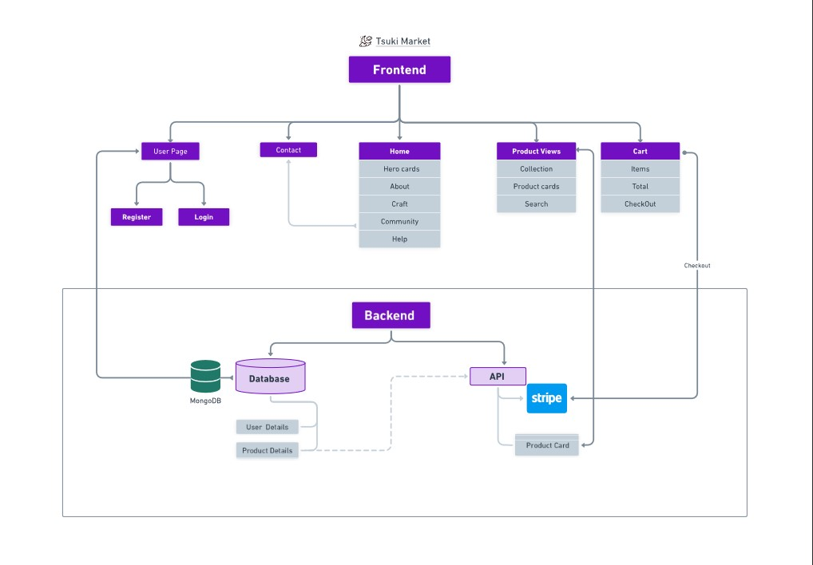

Fig- 1.2 User Flow

Object-Oriented Design Approach:

* Modular architecture with separate Frontend and Backend components.

Frontend Module:

* User Authentication (User Page, Register, Login)
* Navigation (Contact, Nav Links)
* Product Display (Project Views, Product Cards, Search)
* Shopping Cart Management (Cart, Total, Checkout)
* Submodules interact seamlessly to provide a cohesive user experience.

Backend Module:

* Database Module (MongoDB)
  + Stores user details and product information.
  + NoSQL database for flexible data storage and schema evolution.
* API Module
  + Handles CRUD operations for products.
  + Integrates with third-party services like Stripe for payment processing.

Communication:

* Frontend and Backend communicate through the API module.
* Frontend sends HTTP requests to the API.
* API processes requests, interacts with the Database Module, and returns responses.

Technologies and Frameworks:

* Frontend: React or Angular
* Backend: Node.js with Express
* Stripe integration follows API documentation and best practices for secure payment handling and PCI compliance.

Design Principles:

* Modular design and separation of concerns for maintainability and scalability.
* Potential for future feature enhancements or integrations.

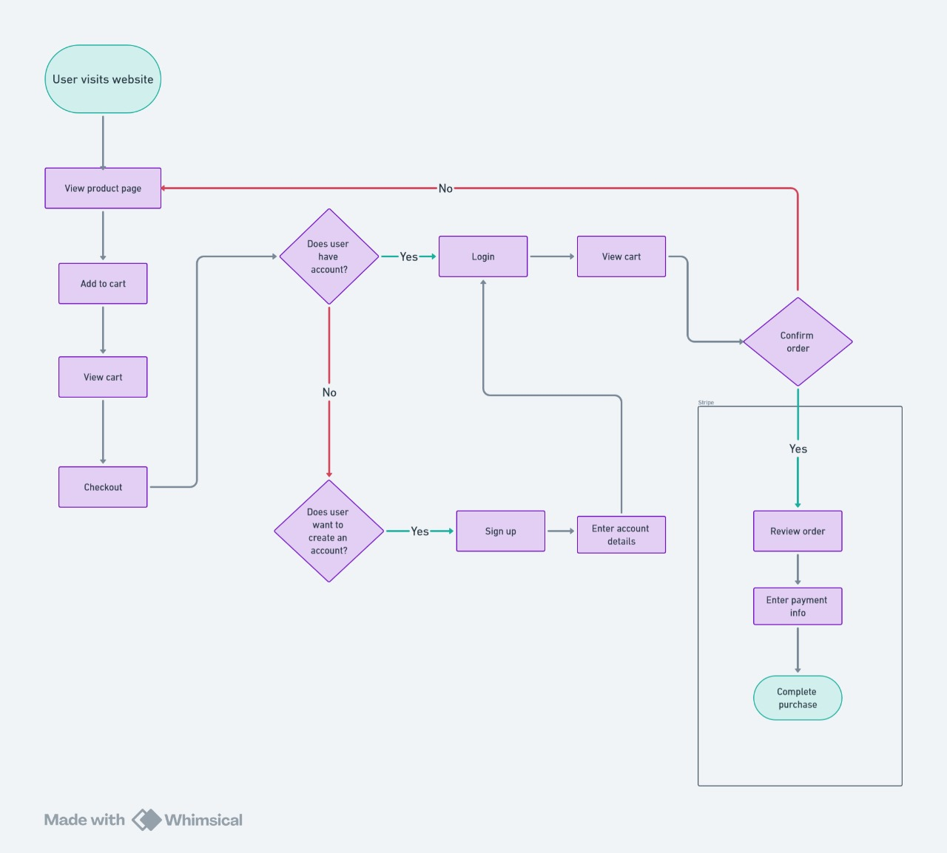Fig -1.2 User Flow

## Details of Hardware and Software Requirements

### For Software:

* + 1. **React JS:** React.js is a popular JavaScript library developed by Facebook for building user interfaces, emphasizing component-based architecture. It enables developers to create interactive and dynamic web applications with efficient data binding and state management.
    2. **Node JS:** Node.js is a runtime environment built on Chrome's V8 JavaScript engine, enabling developers to execute JavaScript code outside of a web browser. It's commonly used for building scalable and high-performance server-side applications.
    3. **ExpressJS:** Express.js is a minimalist web application framework for Node.js, providing a robust set of features for building web servers and APIs. It simplifies the process of handling HTTP requests, routing, middleware integration, and template rendering.
    4. **MongoDB:** MongoDB is a popular NoSQL database management system, known for its flexibility, scalability, and ease of use. It stores data in a flexible, JSON-like format, making it well-suited for handling unstructured or semi-structured data in modern web applications.
    5. **NPM (Node Package Manager):** React relies on Node.js and its package manager, npm, for managing dependencies and running build scripts.

**For Hardware:**

**Operating System:**

* Windows: 7 (32/64 bit) or higher, preferably 10 or 11
* macOS: 10.10 or higher
* Linux: Ubuntu 16 or higher

**Hardware:**

* **Processor:** A modern dual-core or better processor is recommended.
* **RAM:** 4GB of RAM is the minimum, but 8GB or more is ideal for a smoother experience, especially with larger projects.
* **Storage:** At least 10GB of available storage space is needed for React itself and its associated tools and dependencies.

**Other Requirements:**

* **Web browser:** A modern web browser like Chrome, Firefox, Edge, or Safari is essential for viewing and testing React applications.
* **Code editor:** A code editor or IDE (Integrated Development Environment) is necessary for writing and editing React code. Popular choices include Visual Studio Code, Atom, Sublime Text, and WebStorm.

**Recommended Specifications for Optimal Performance:**

* **Processor:** Intel Core i5 or equivalent
* **RAM:** 8GB or more
* **Storage:** SSD for faster loading times
* **Display:** Full HD (1920x1080) resolution or higher

## Chapter 4

**Results and Discussion**

Tsuki serves as an online platform for businesses to buy products. It facilitates transactions through secure payment gateways, enabling users to browse, select, and purchase items conveniently. Features like product catalogs, search functionality, customer reviews, and personalized recommendations enhance user experience and drive sales. Effective inventory management ensures accurate product availability information and timely order fulfillment. Integration with logistics and shipping partners streamlines delivery processes, ensuring prompt and reliable product delivery.

Tsuki has revolutionized the way businesses operate, enabling online transactions, global reach, and seamless customer experiences. Its growth is fueled by technological advancements, changing consumer preferences, and the convenience of shopping anytime, anywhere. However, challenges such as security concerns, competition, logistics, and maintaining customer trust require strategic planning and adaptation.

This section provides an overview of the project outcomes, including screenshots and key results derived from the implementation of the e-commerce.

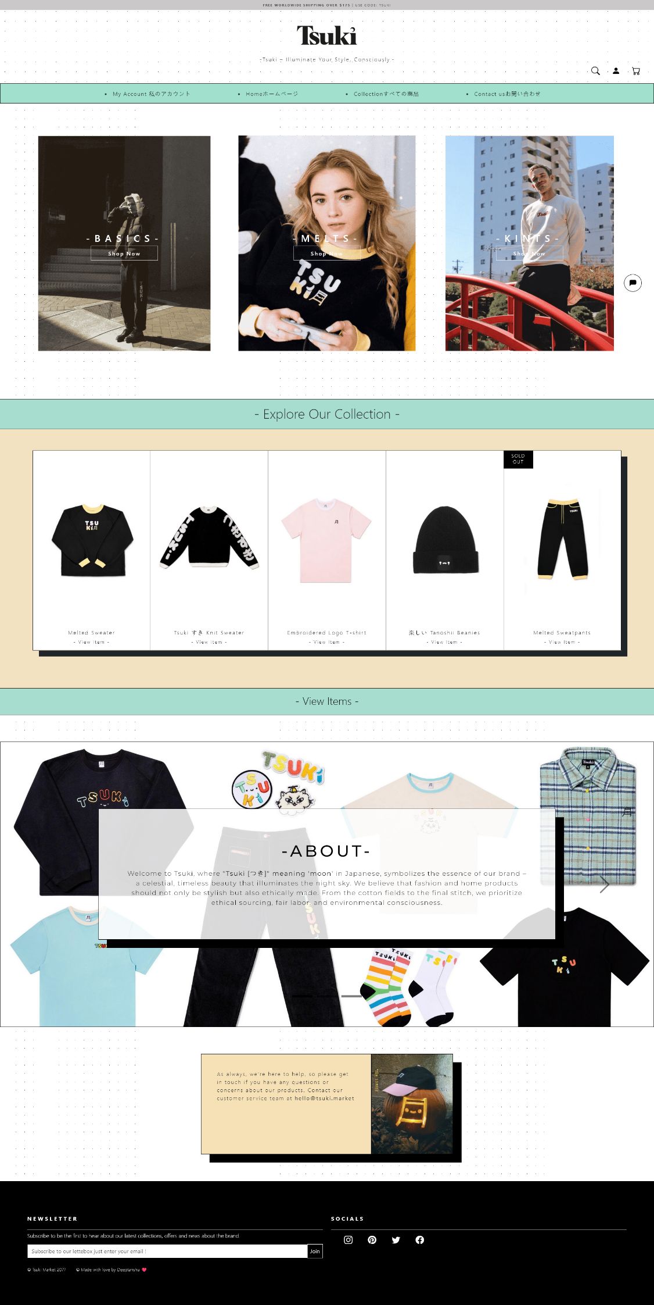

Fig-1.1 Home Page

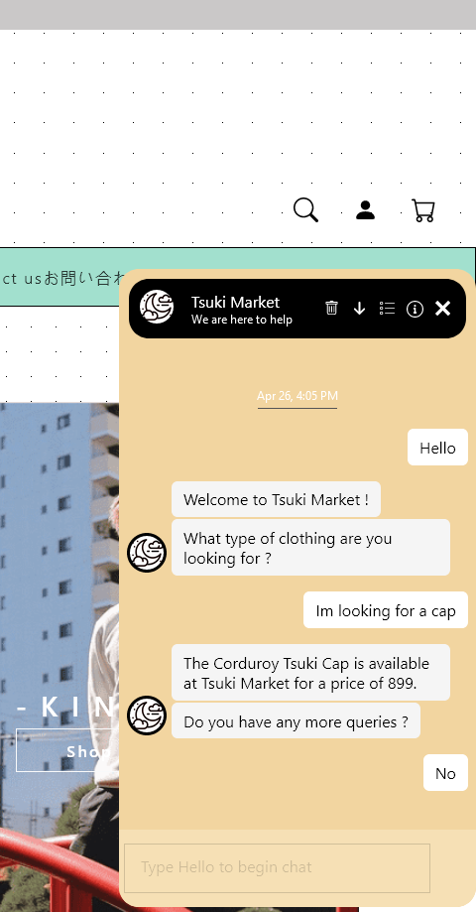

Fig-1.1a AI Chat Bot

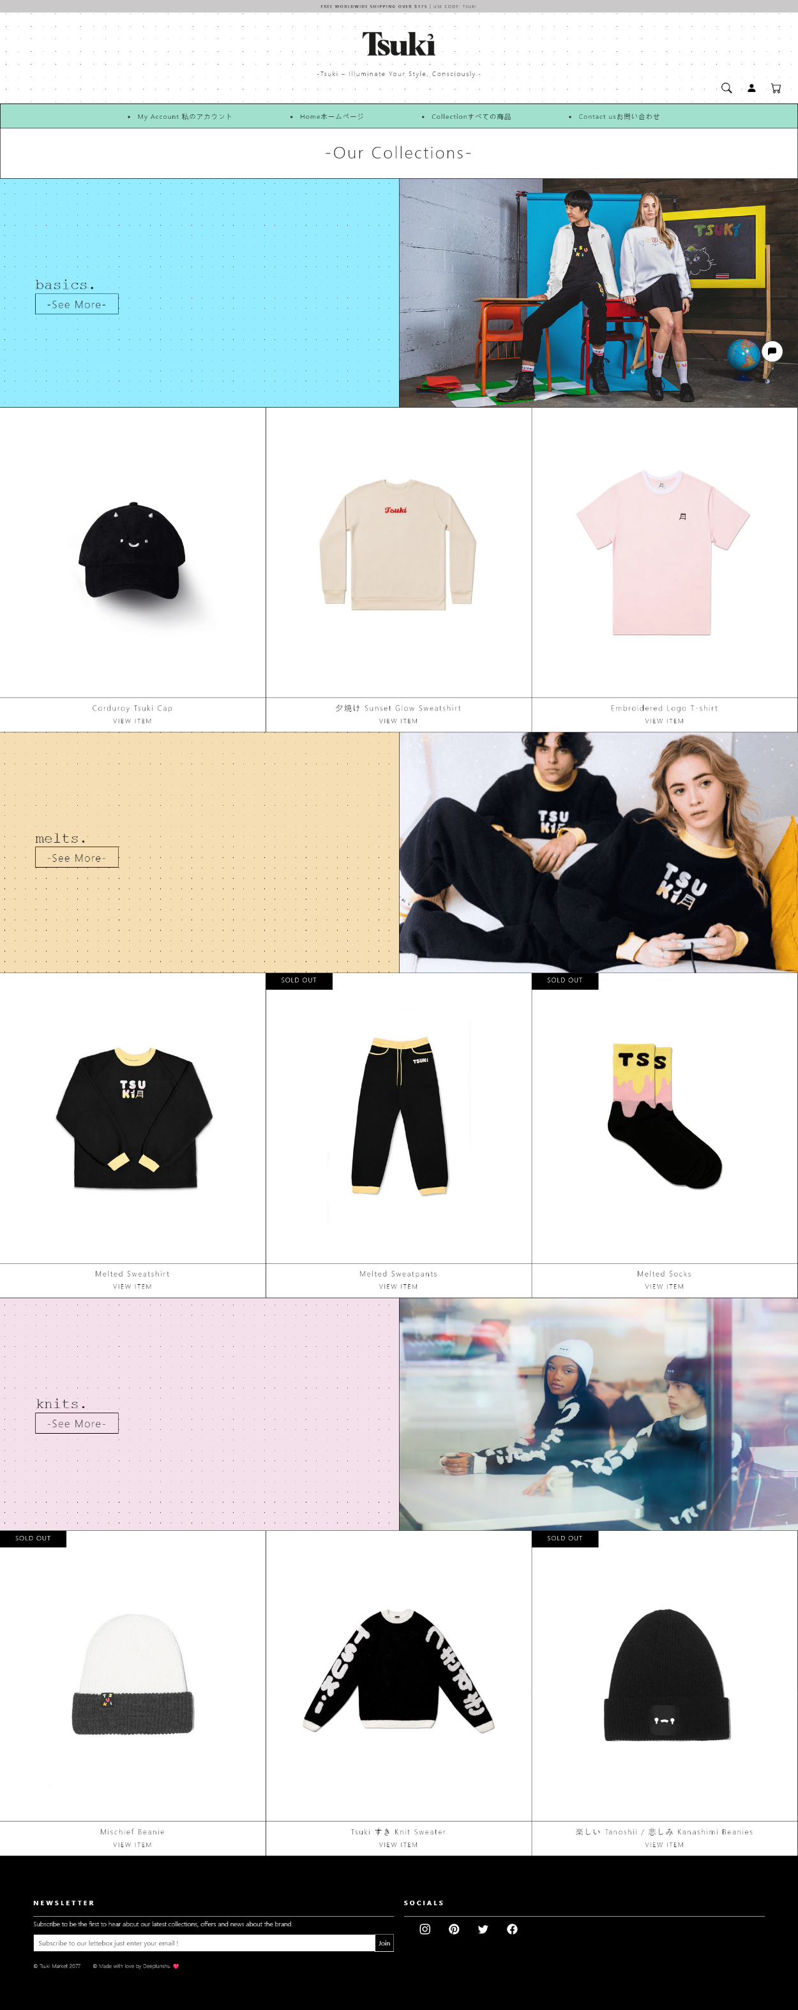

Fig-1.2 Collection Page

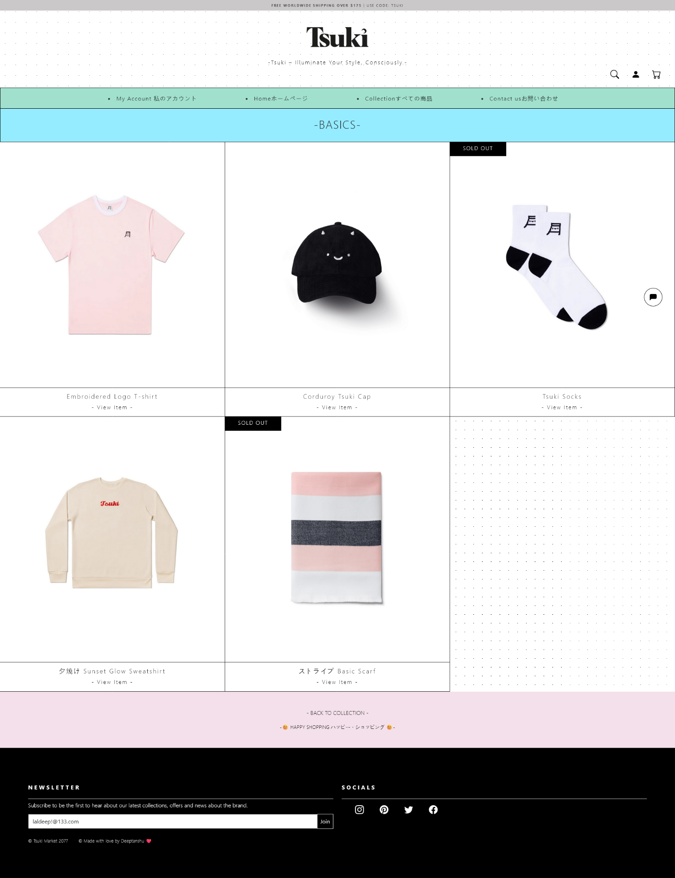

Fig-1.2a Category Page

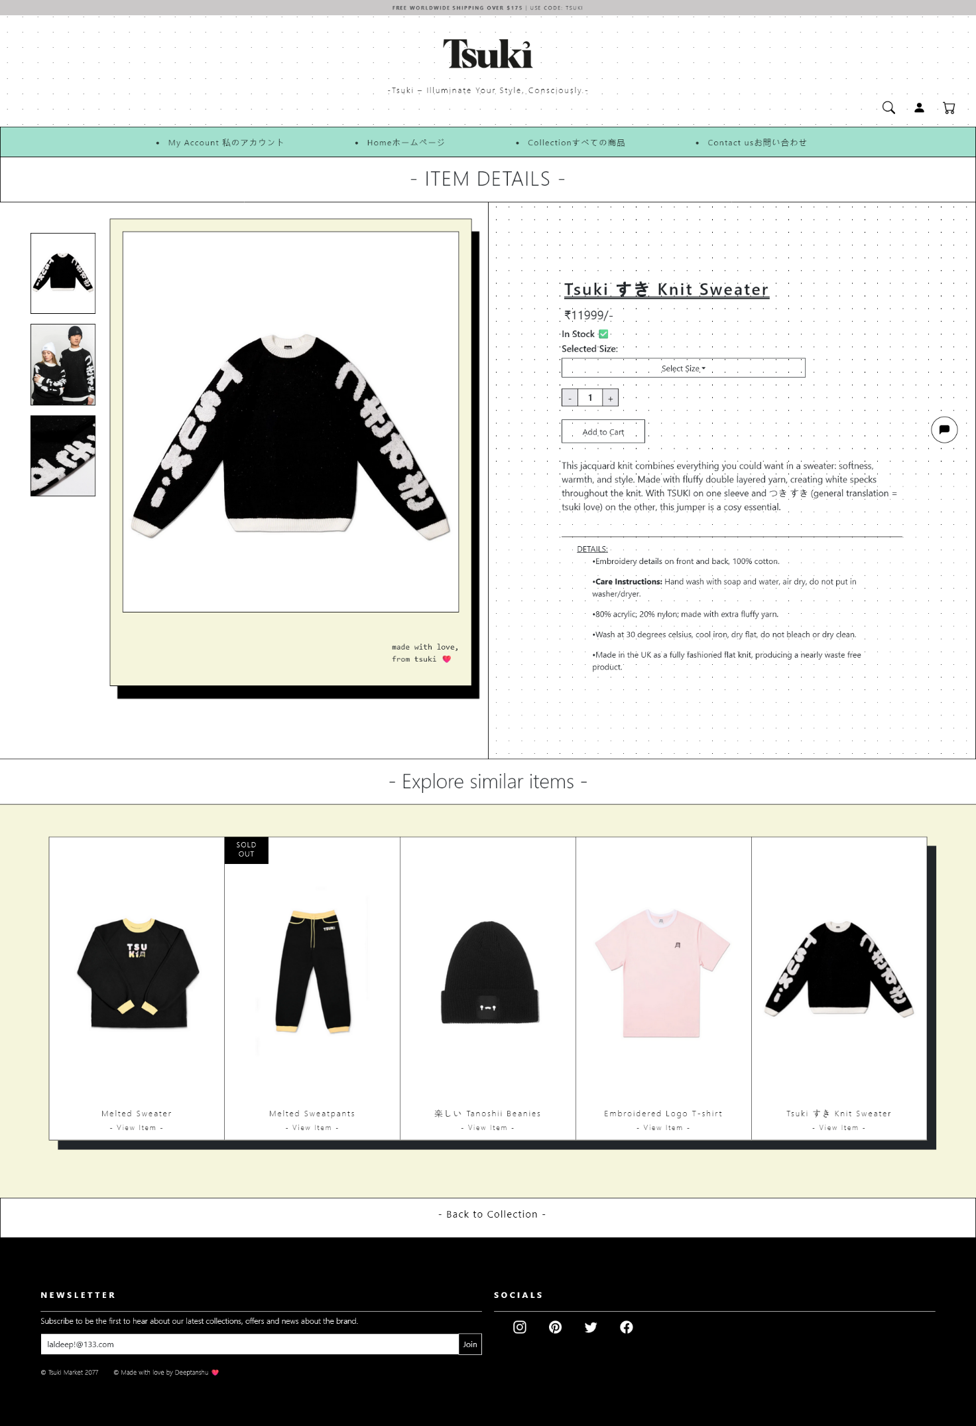

Fig-1.3 Product page

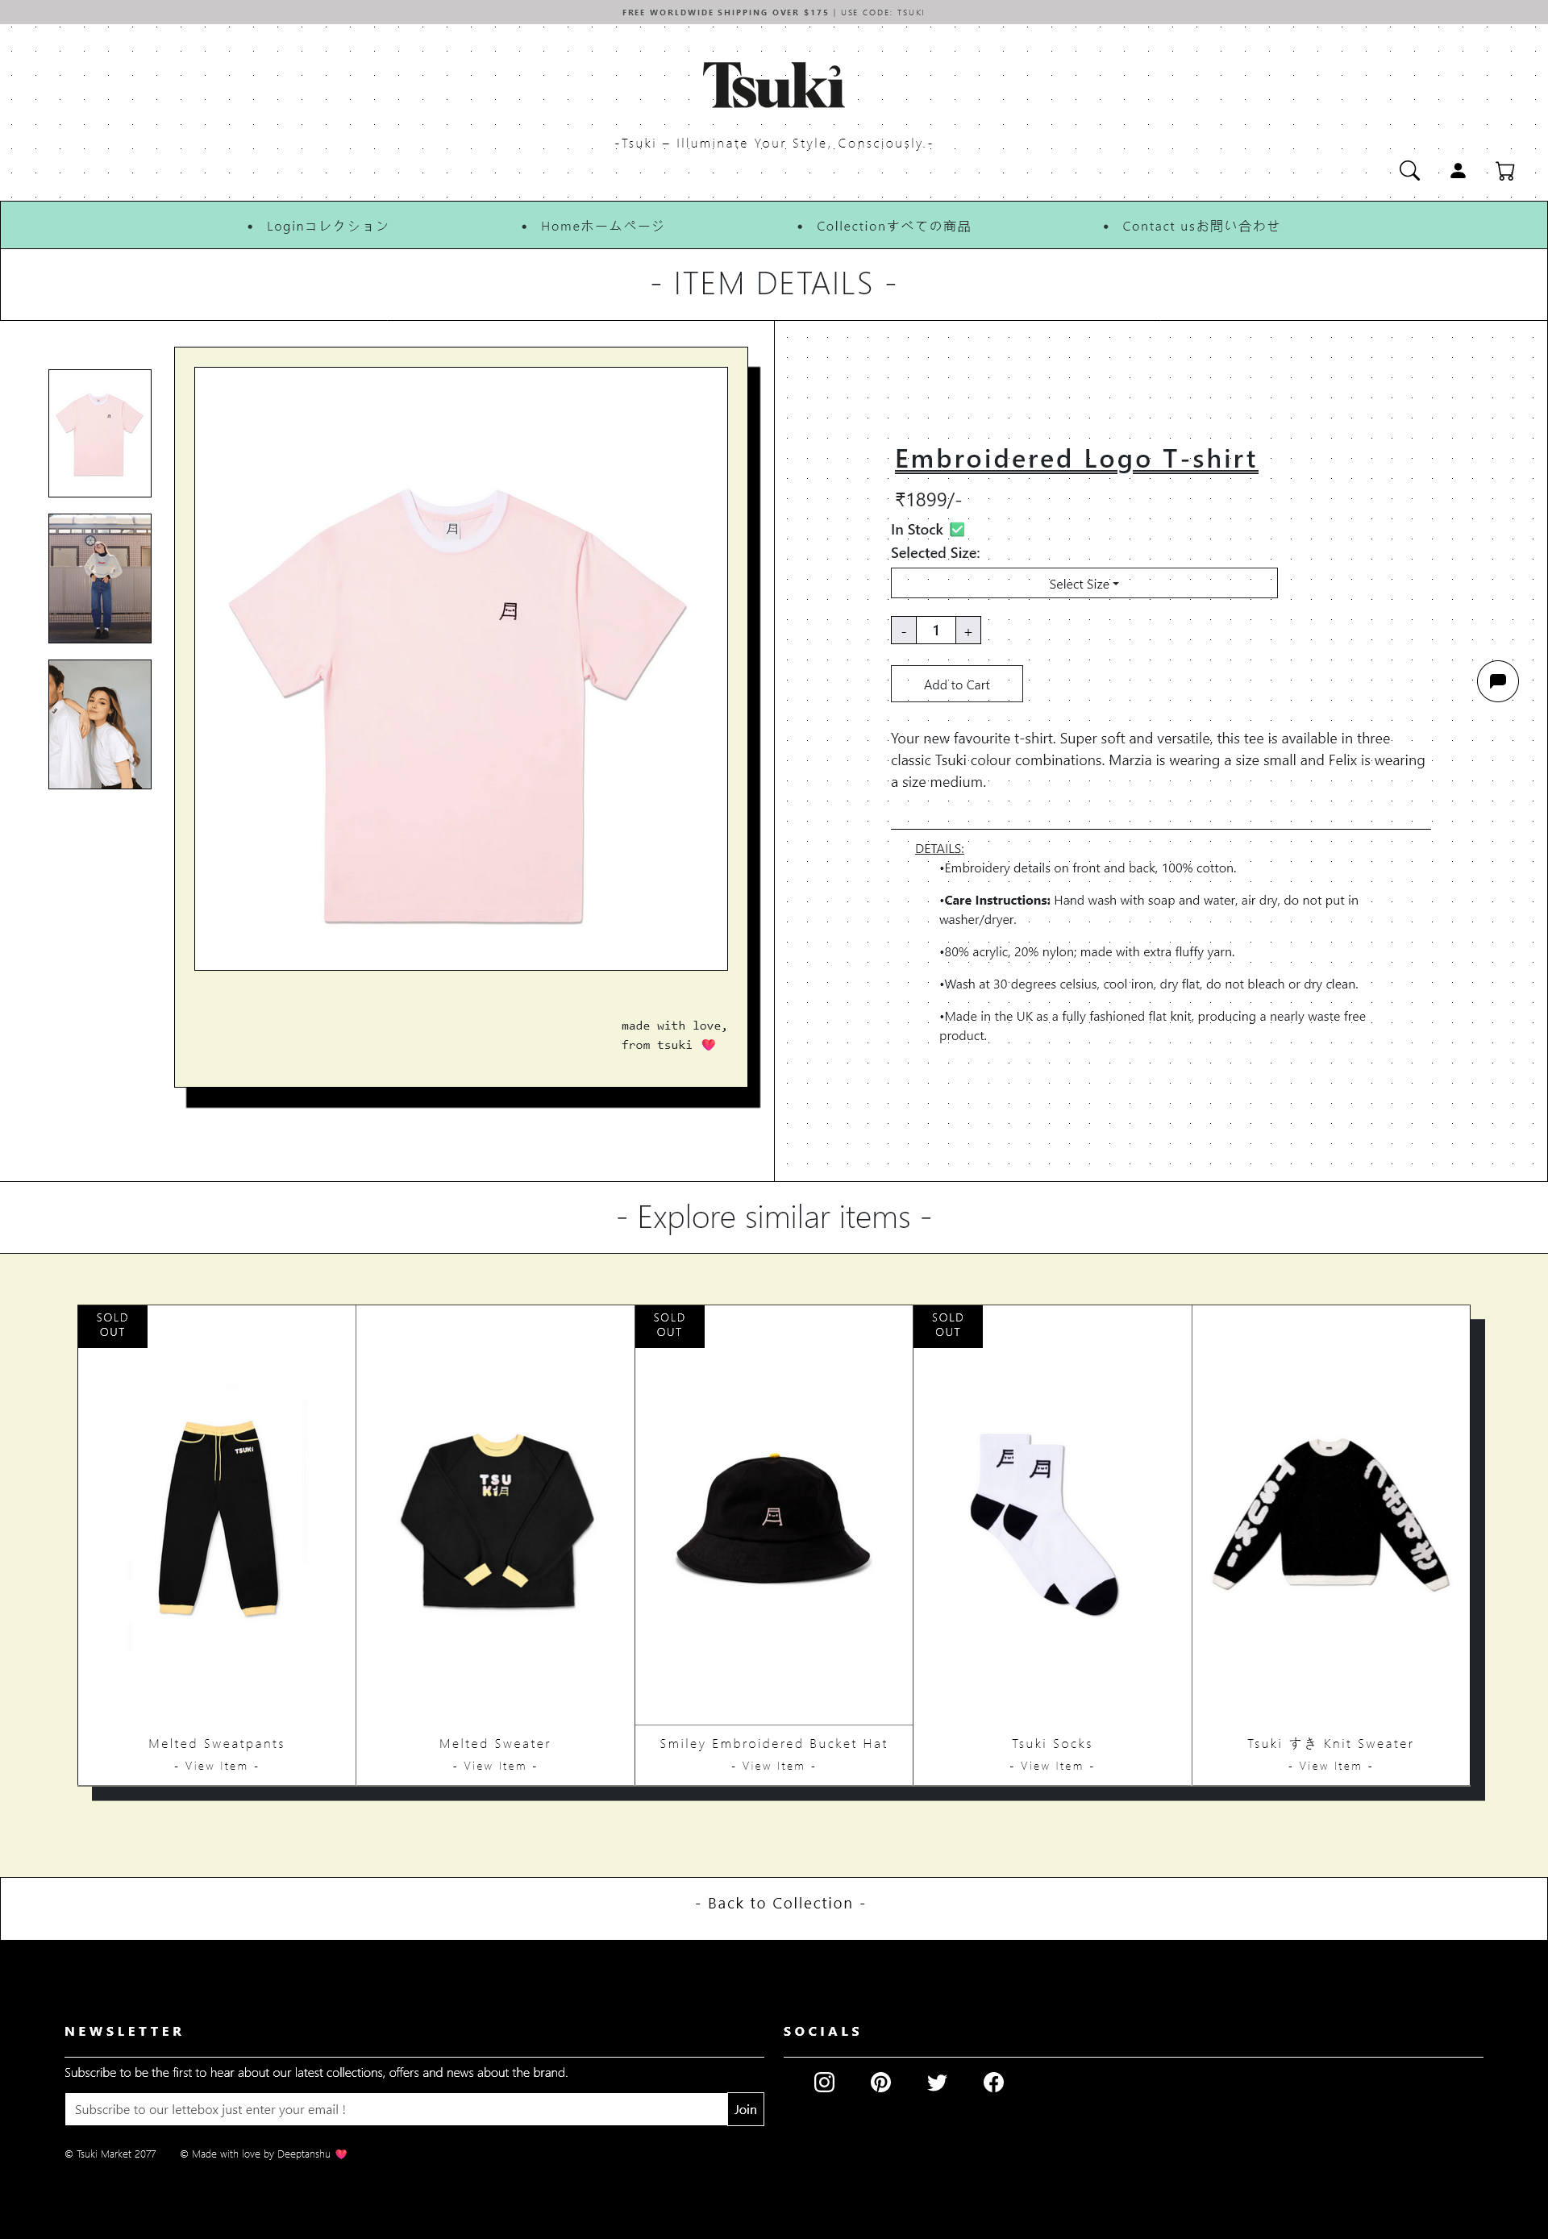

Fig- 1.3a Product Page

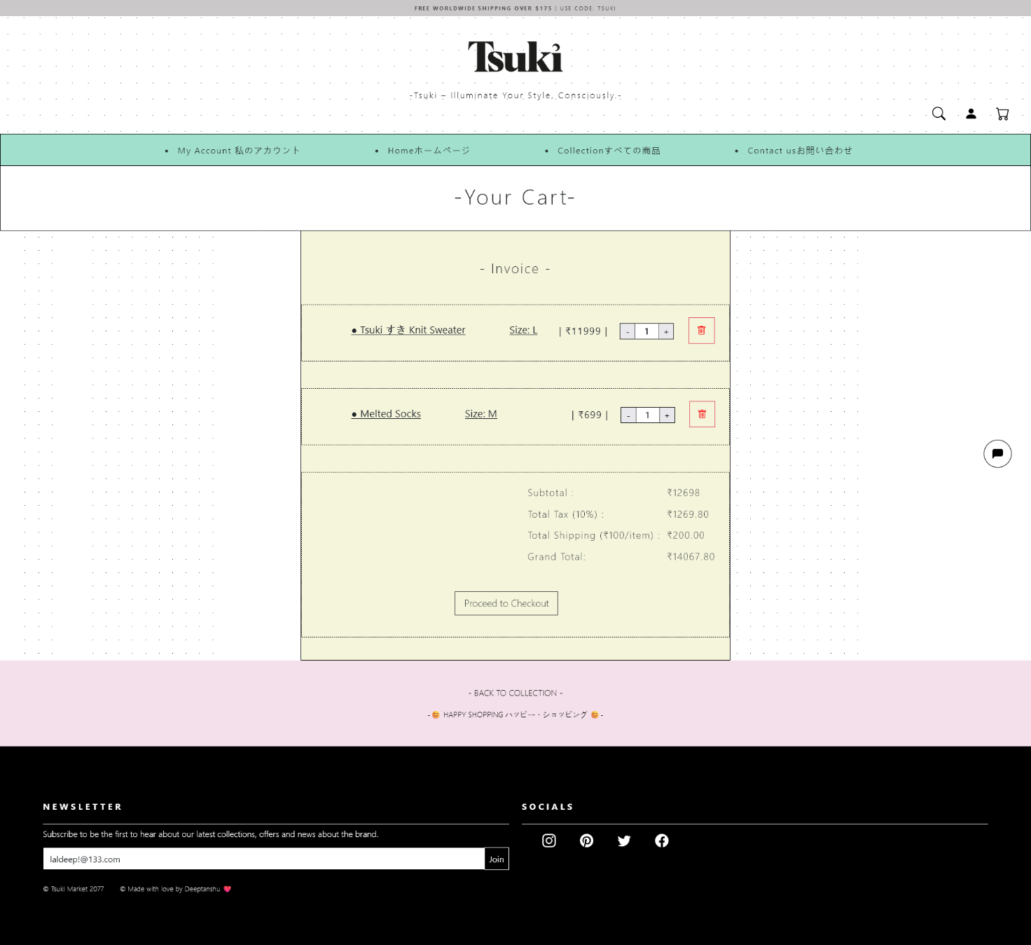

Fig-1.4 Cart page

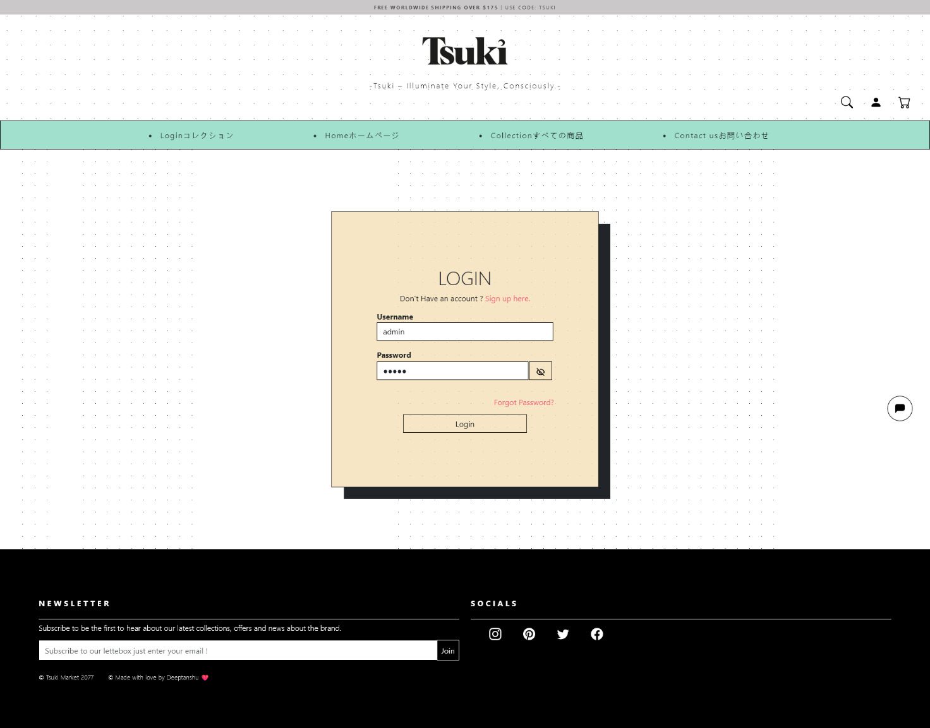 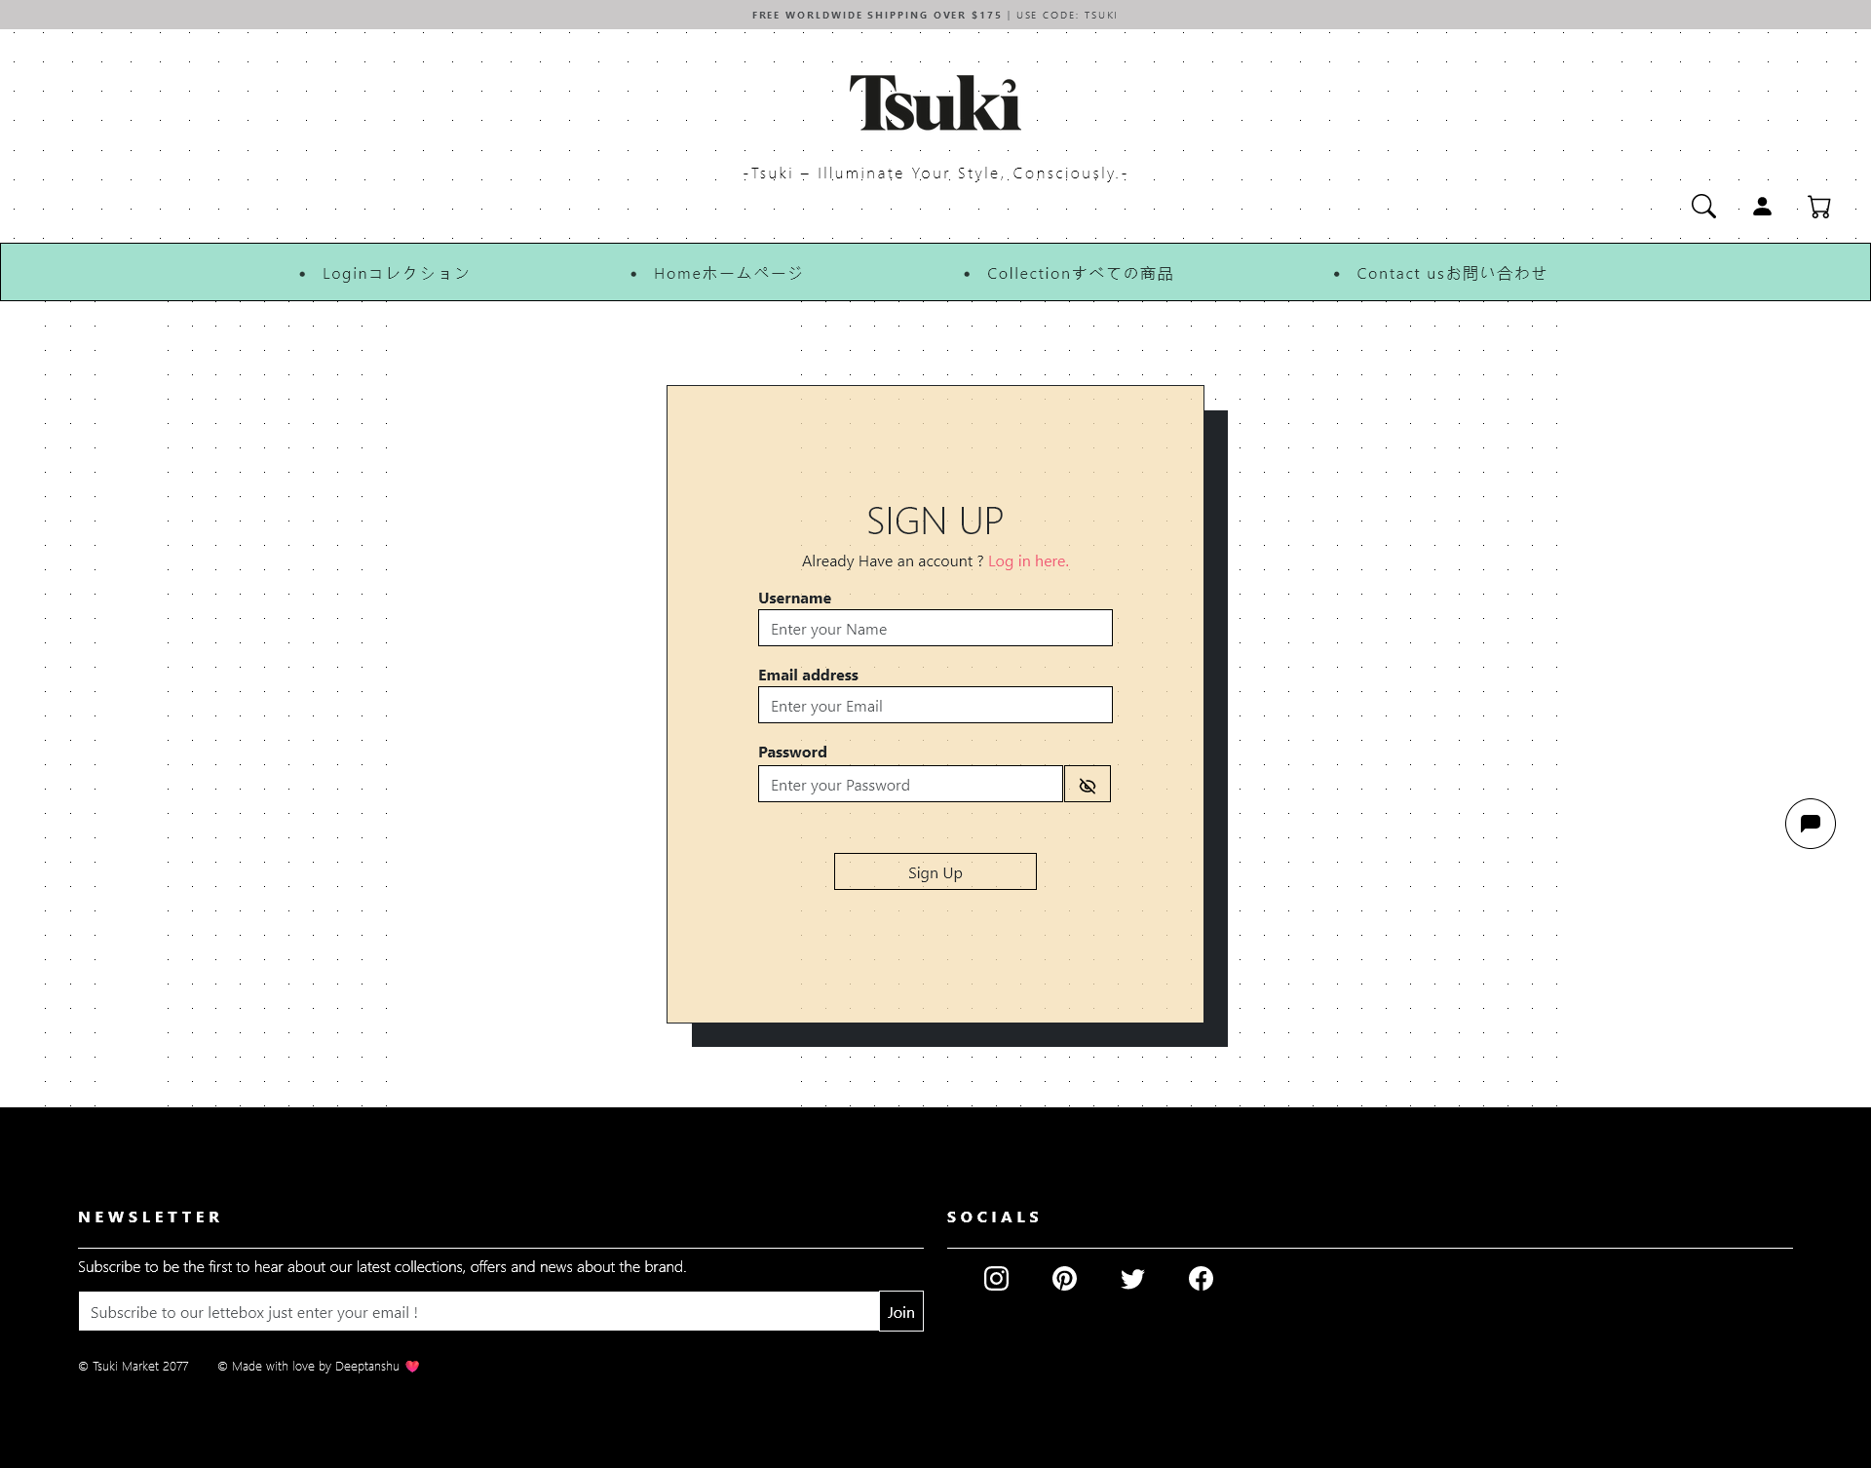

Fig-1.5/1.6 Login /Sign -Up Page

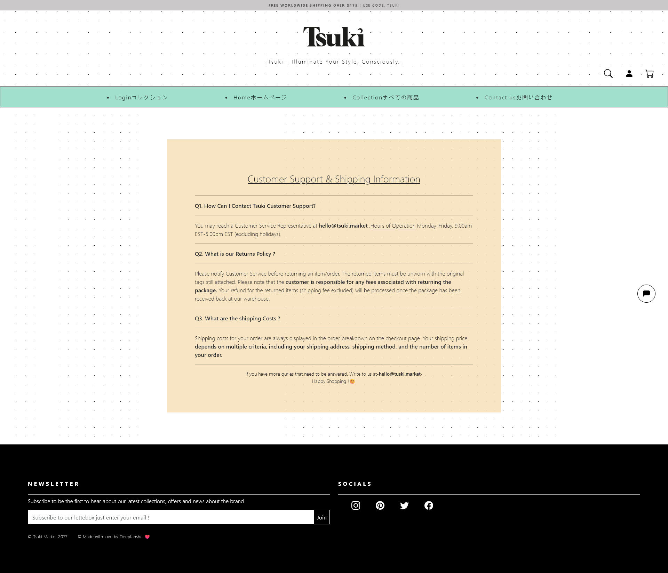

Fig-1.7 Contact page

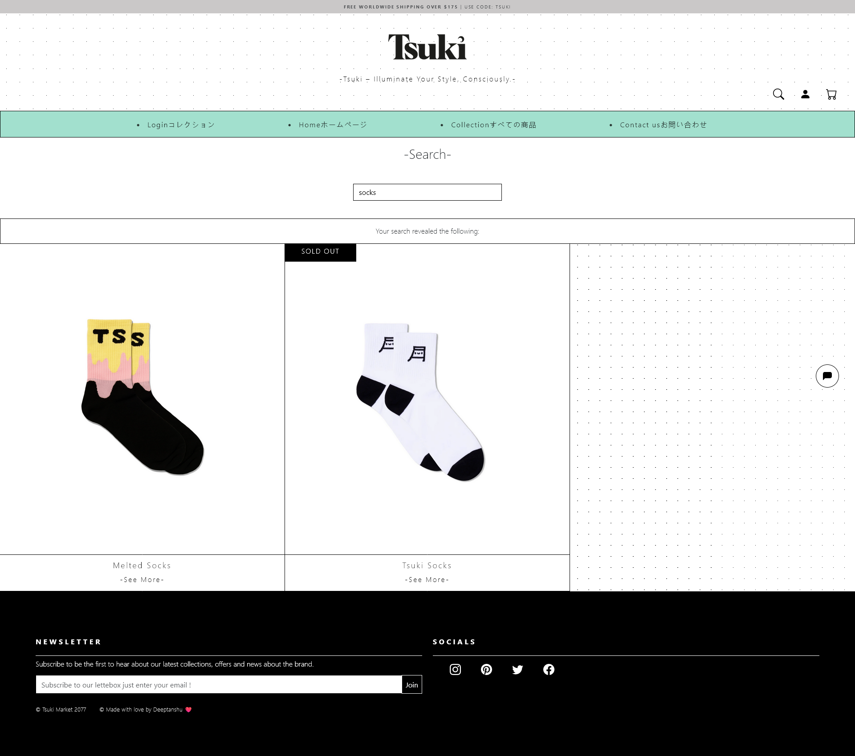

Fig-1.8 Search Page

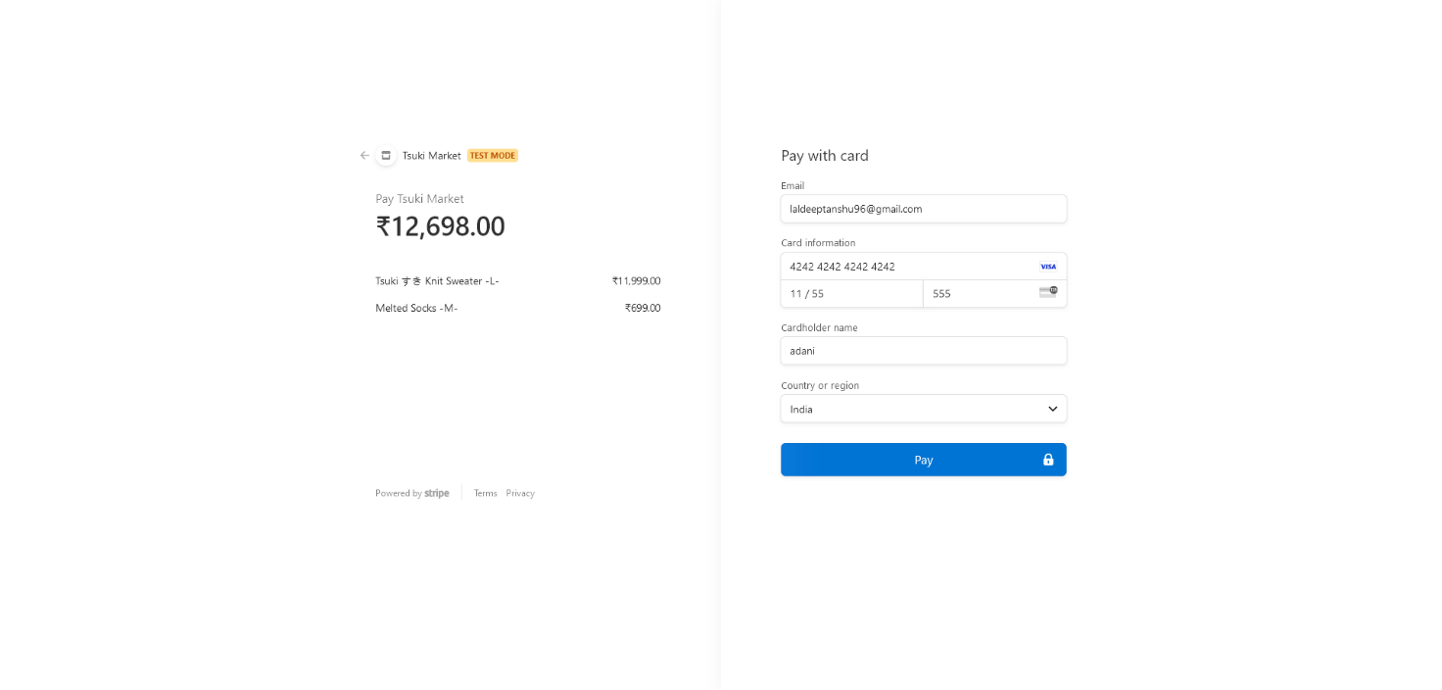

Fig-1.8 Payment Page (Stripe)

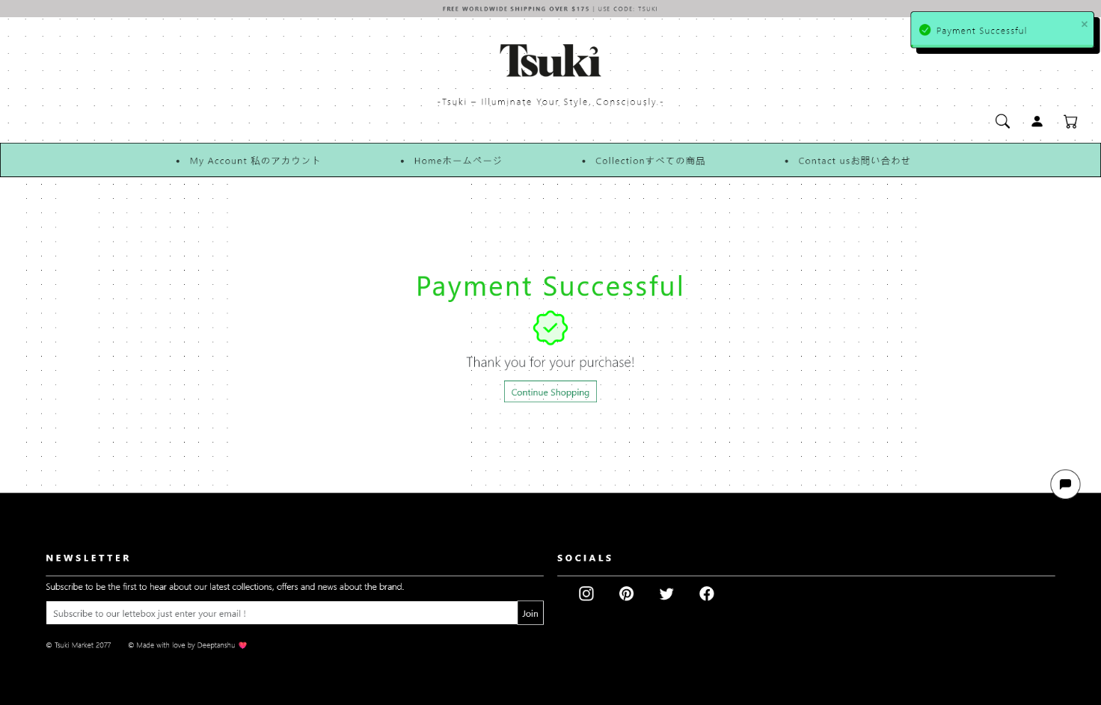

Fig-1.8a Successful Transaction Page

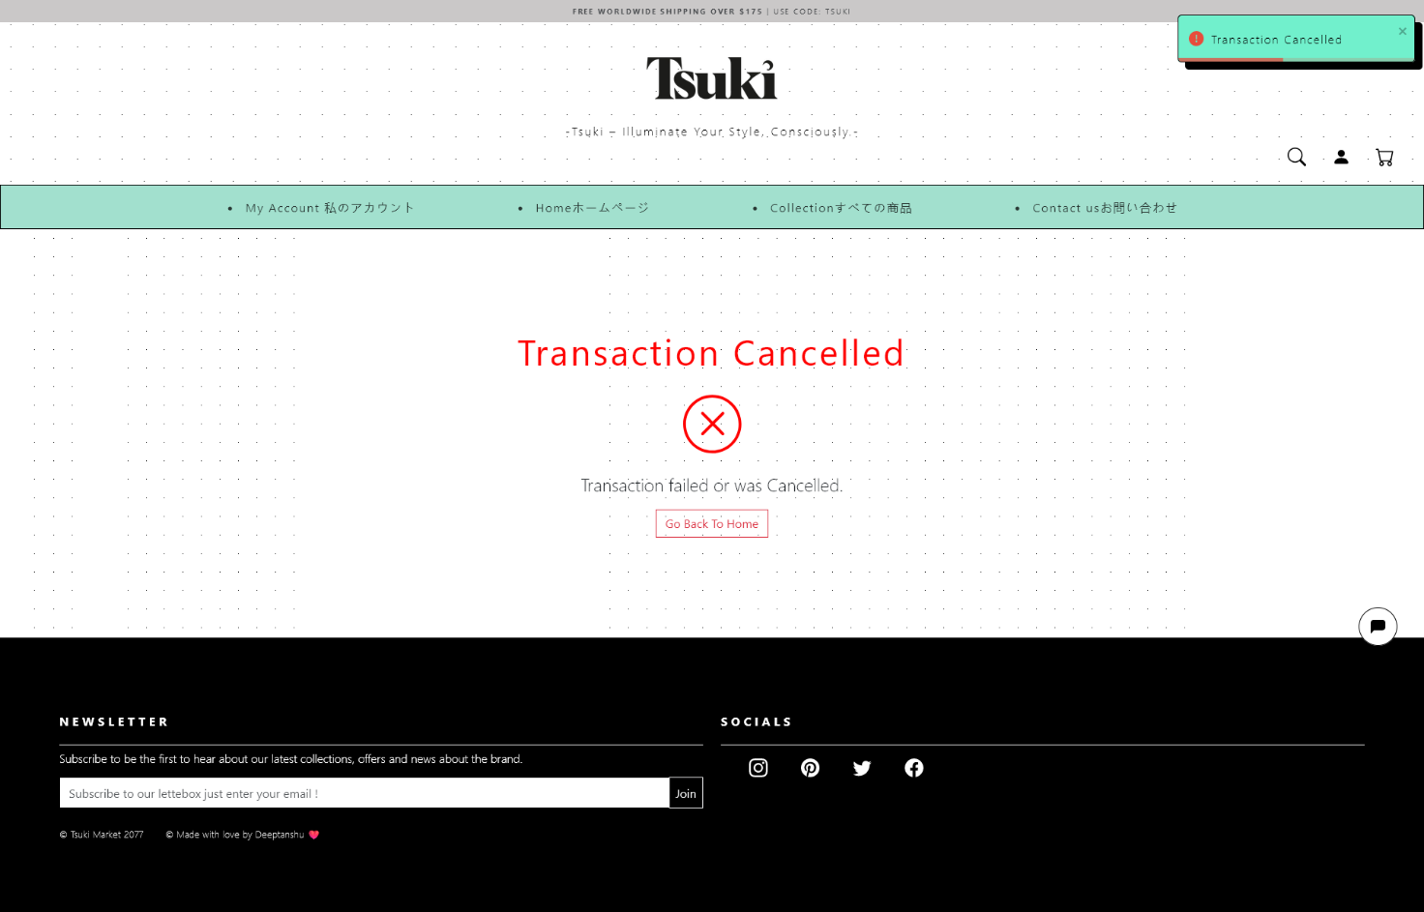

Fig – 1.8b Cancelled Transaction Page

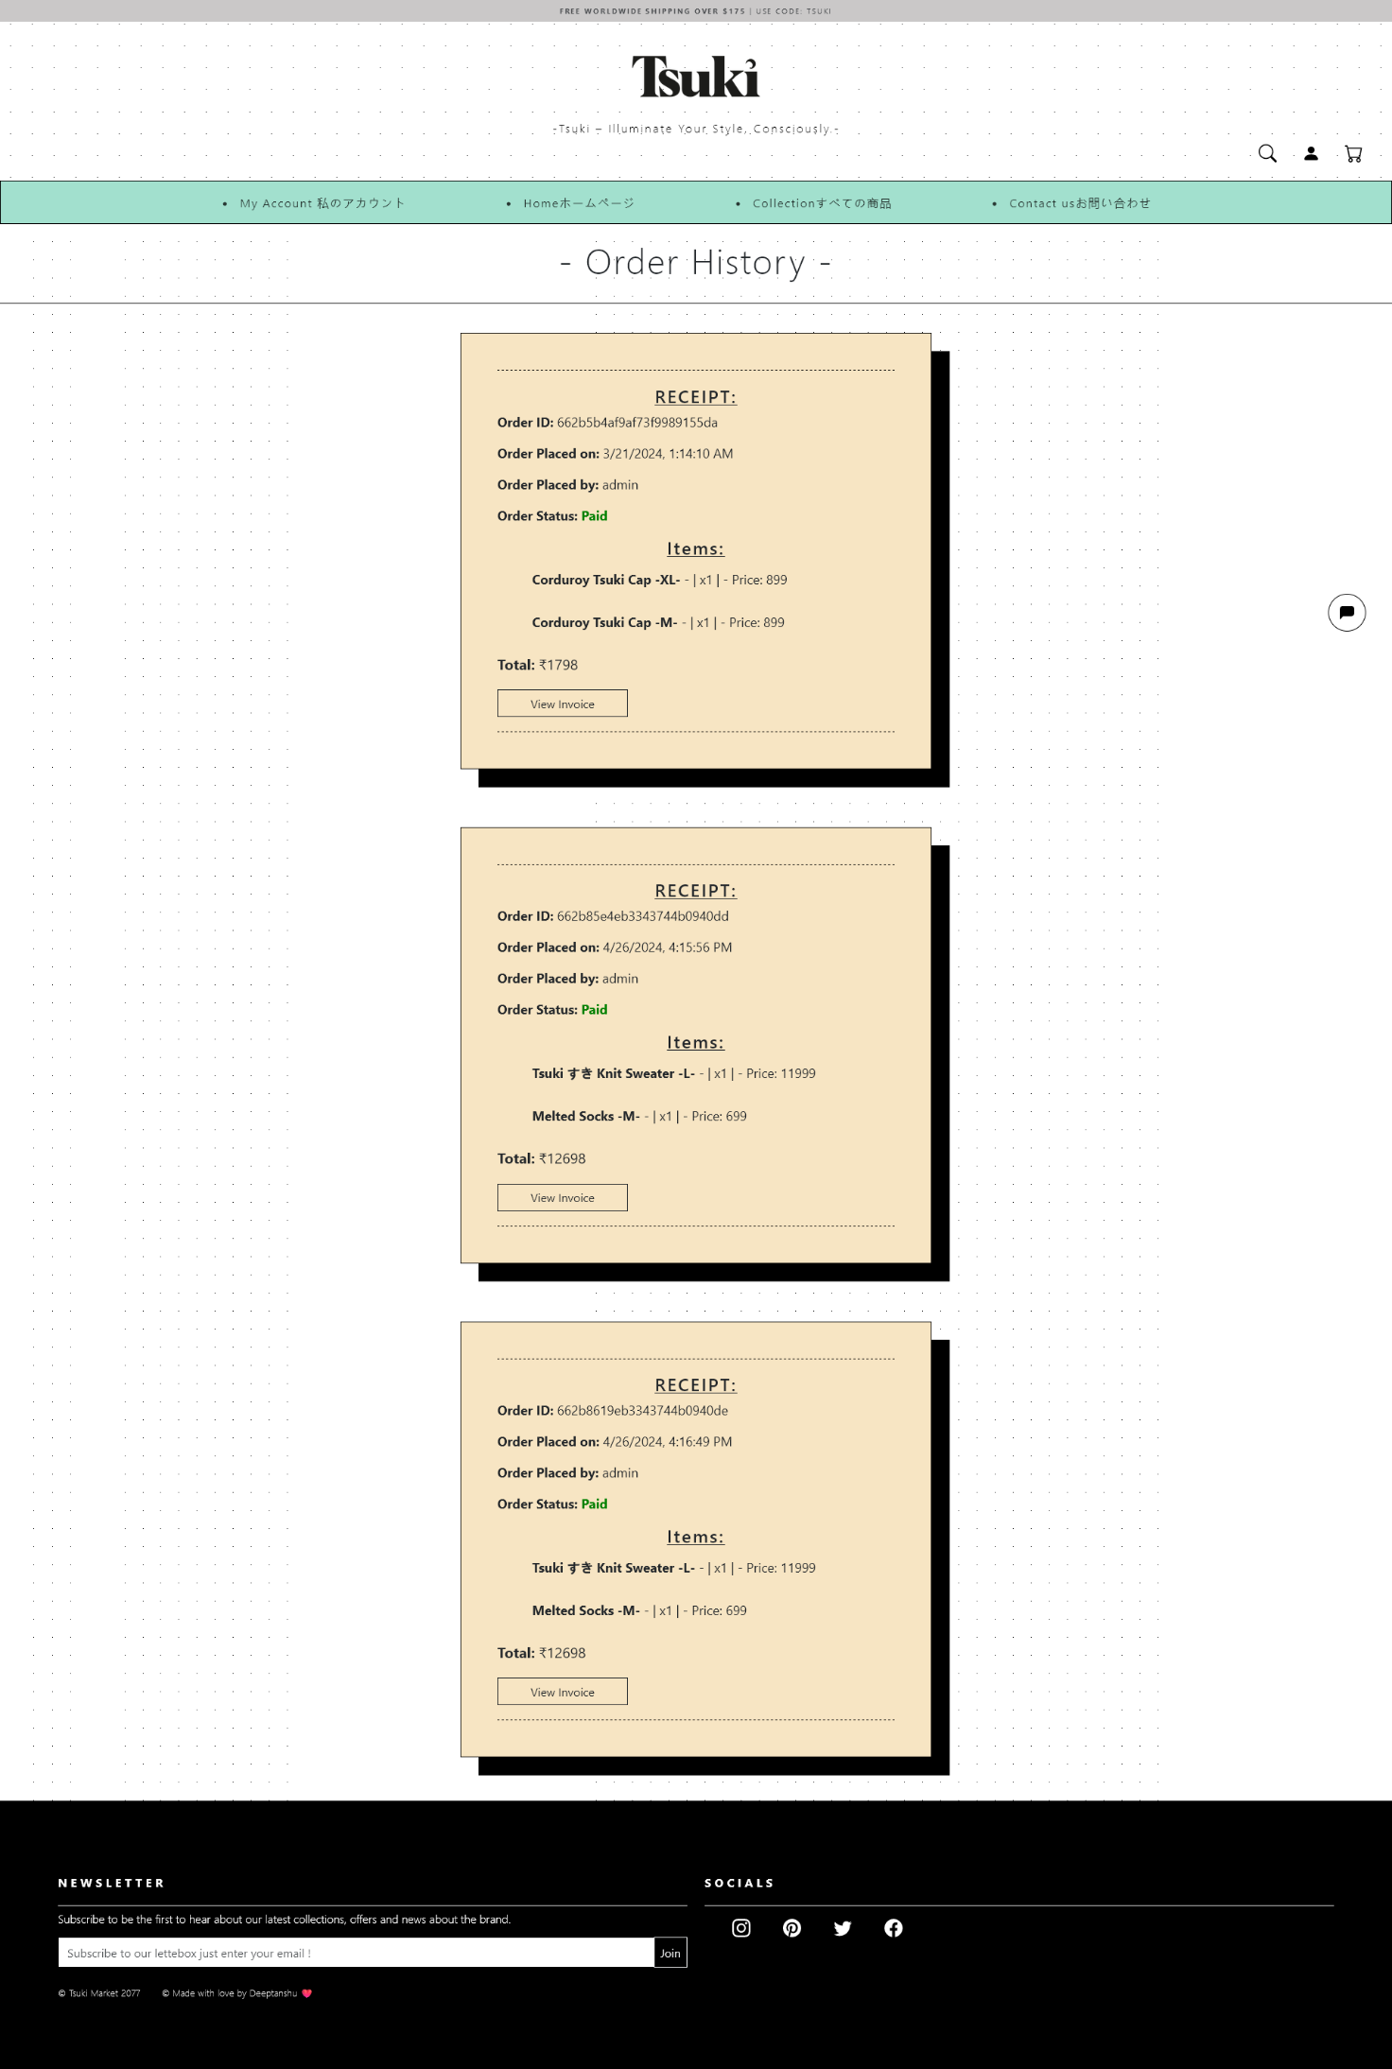

Fig – 1.9 Order History

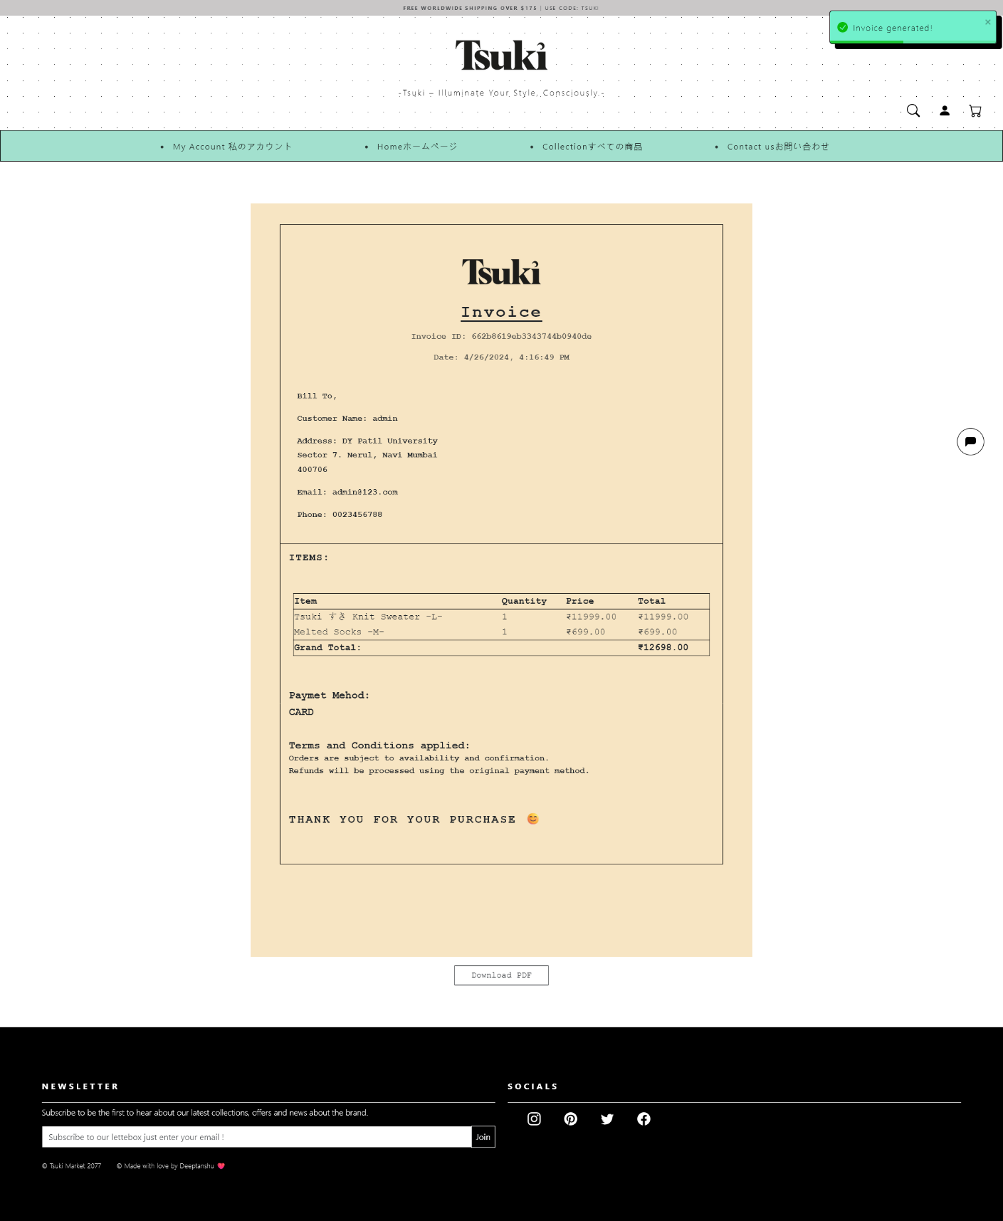

Fig – 1.10 Invoice Page

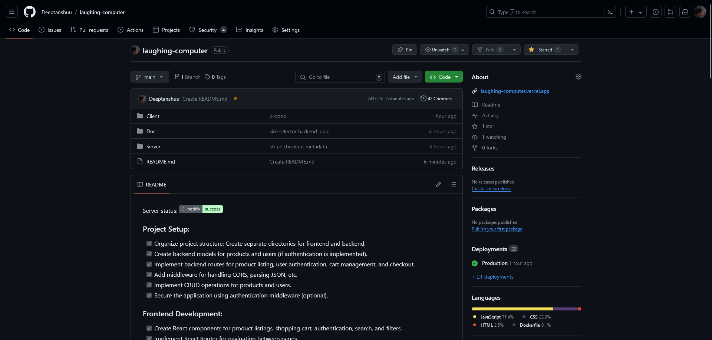

Fig-2.1 GitHub page

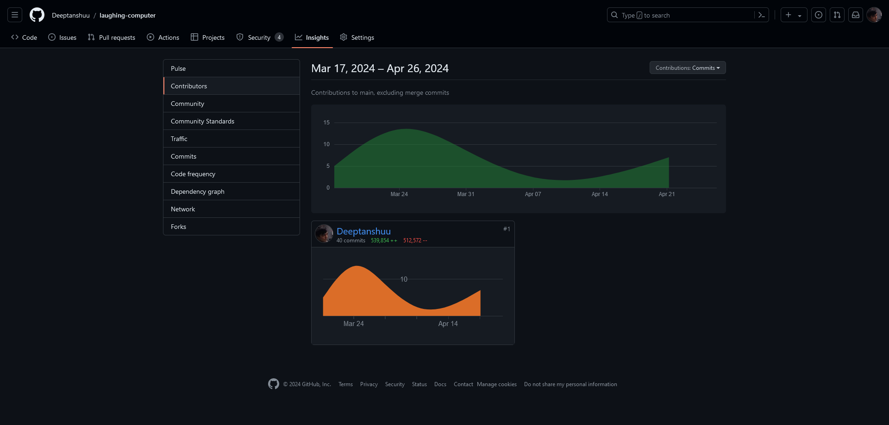

Fig-2.1 GitHub Contribution page 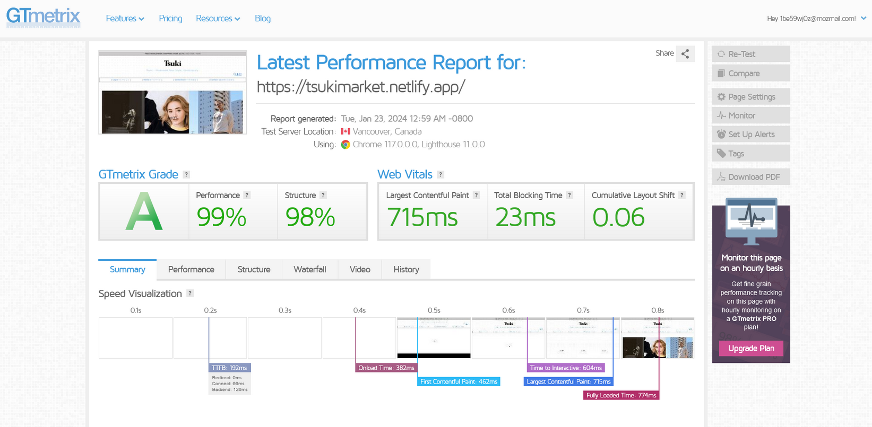

Fig-3.1 GTmetrix page

(indication of performance of the website)

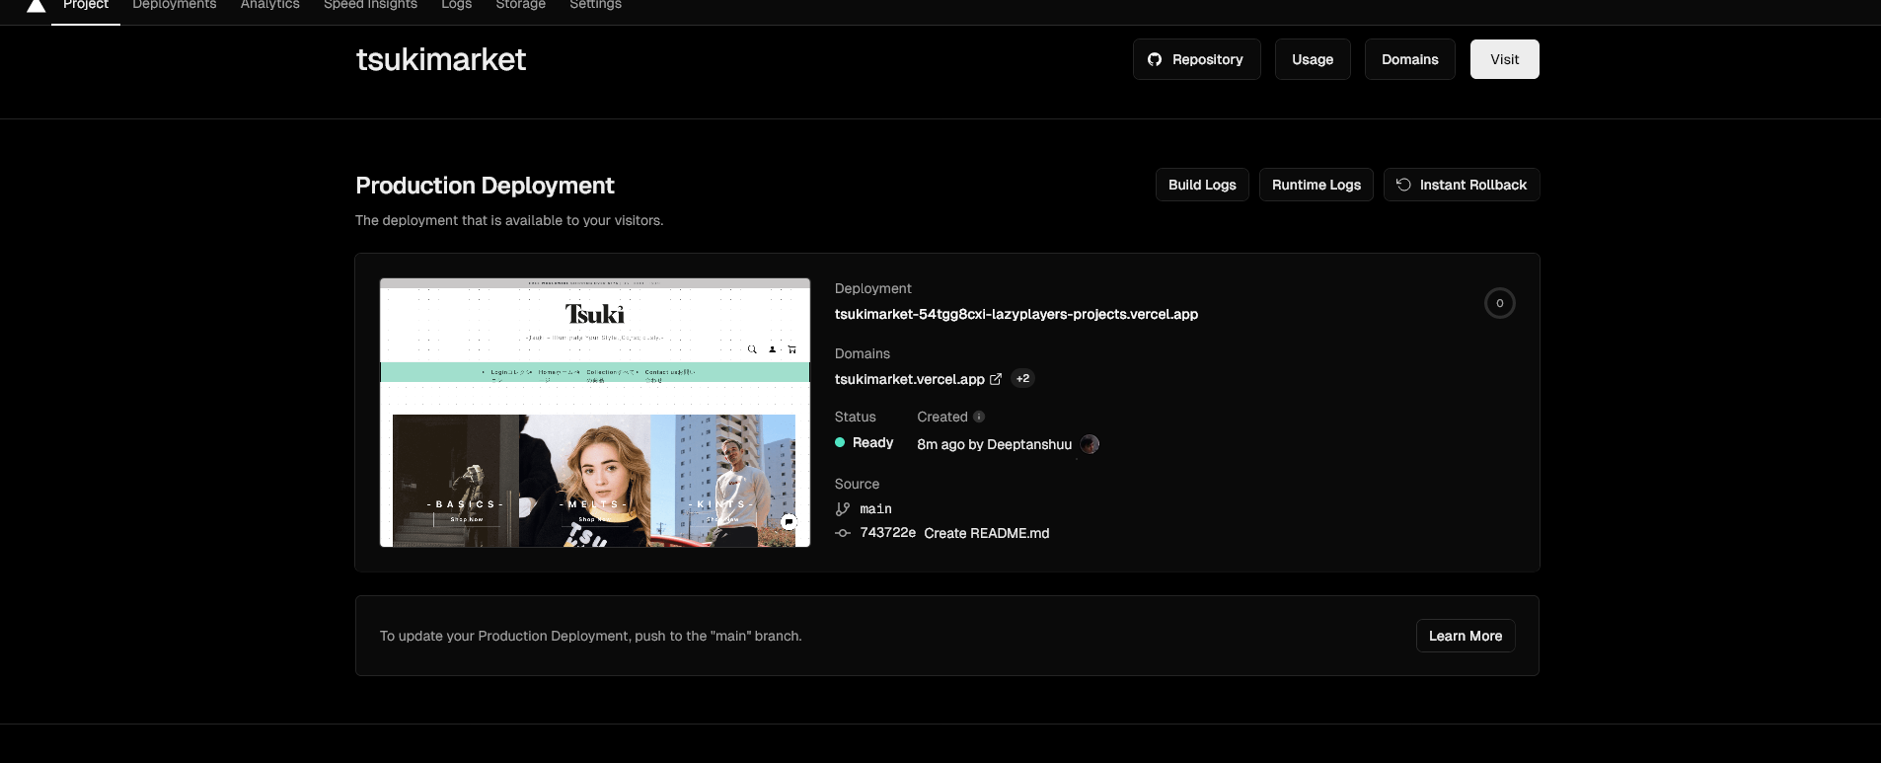

Fig- 3.2 Vercel Deployment Page

(Platform used to deploy the website)

# Chapter 5

## Conclusion and Future work:

In conclusion, the development of our e-commerce website project has provided invaluable insights into the integration of modern web technologies and methodologies to create a dynamic and user-centric platform. By leveraging tools such as React.js, Node.js, Express.js, and MongoDB, we have constructed a robust system capable of delivering a seamless shopping experience to users.

Through the implementation of responsive design principles, we have ensured that our e-commerce website is accessible across a variety of devices and screen sizes, catering to the diverse needs of our user base. This adaptability enhances user engagement and satisfaction, contributing to a positive overall shopping experience.

Furthermore, we can consider integrating additional features and functionalities into our e-commerce catalog, such as user authentication and authorization, product recommendations based on user behavior, and social media integration for enhanced sharing and engagement. These enhancements would enrich the overall user experience and contribute to the continued growth and success of our platform.

### References

1. Books:
   * "E-Commerce 2020: Business, Technology, Society" by Kenneth C. Laudon and Carol Guercio Traver.
   * "The Everything Store: Jeff Bezos and the Age of Amazon" by Brad Stone.
   * "E-Commerce Essentials" by Kenneth C. Laudon and Carol Guercio Traver.
2. Research Reports & Journals:

* Reports from leading market research firms such as Gartner, Forrester, and Statista on e- commerce trends, statistics, and forecasts.
* Academic journals like the "Journal of Electronic Commerce Research" provide scholarly articles on e-commerce theories, practices, and innovations.

1. Websites & Online Platforms:

* Websites of prominent e-commerce companies like Amazon, Alibaba, eBay, and Shopify for insights into their business models, strategies, and best practices.

1. Courses & Online Learning Platforms:

* E-commerce courses offered by universities, online learning platforms like Coursera, edX, and Udemy provide structured learning materials, lectures, and case studies on e- commerce topics.

**ACKNOWLEDGEMENT**

We take this opportunity to express my profound gratitude and deep regards to my guide Mrs. **Shital Patil** for his/her exemplary guidance, monitoring and constant encouragement throughout the completion of this report. We are truly grateful to his/her efforts to improve my understanding towards various concepts and technical skills required in our project. The blessing, help and guidance given by her time to time shall carry us a long way in the journey of life on which we are about to embark.

We take this privilege to express my sincere thanks to **Dr. Mukesh D. Patil, Principal, RAIT, D. Y. Patil deemed to be University** for providing the much necessary facilities. We are also thankful to **Dr. A. V. Vidhate,** Head of Department of Computer Engineering, **Dr. Smita Bharne,** Mini Project Co-Ordinator, for their generous support.

Last but not the least we would also like to thank all those who have directly or indirectly helped us in completion of this project report.

Deeptanshu Lal

Krish Pradeshi

**Appendix -I**

# Participation Details

1. Deeptanshu Lal – CSI MERN TECH STACK Internship -2023-2024
2. Krish Pradeshi - None